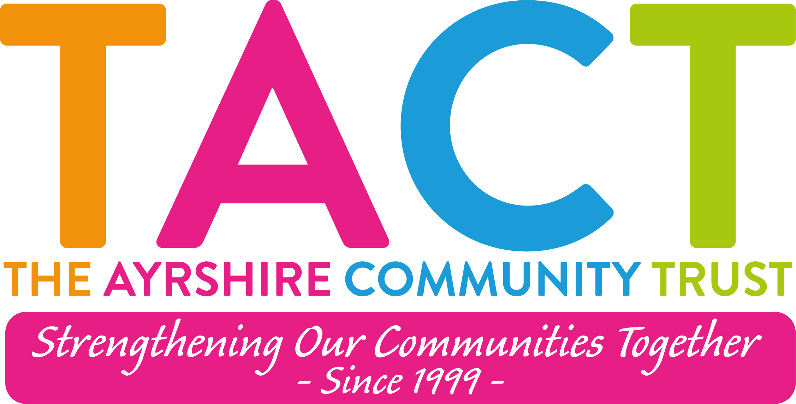

The Ayrshire Community Trust

Job Description

Post: Employment Support Worker (part-time)
Responsible to: Employability Team Leader
Salary: £25,025 (pro-rata)
Contract: Fixed-term until 31st July 2027
Hours: 20 hours (flexible working pattern to be agreed)
Location: Vernon Street, Saltcoats (community-based with travel across mainland localities)

TACT is looking for one exceptional and experienced individual to become a member of the team.

The Role:
The Employment Support Worker will provide one-to-one and group support to individuals who are unemployed or economically inactive, helping them overcome barriers and progress towards employment, training, volunteering, or further education.

The postholder will build positive relationships with participants, develop personalised action plans, provide ongoing encouragement, and signpost clients to appropriate services. They will also work closely with employers, training providers, and community organisations to create opportunities that improve employability and long-term outcomes.

This is an exciting opportunity for someone who is passionate about helping people achieve their goals and make lasting, positive changes in their lives.

About TACT:
The Ayrshire Community Trust (TACT) is a charity based in North Ayrshire that provides programmes and projects that make a difference to people’s lives by encouraging, supporting and promoting community action.

Employee Benefits:
- Real Living Wage Employer
- Four Day Working Week (Monday to Thursday)
- 8% Employer Pension Contributions (after probationary period)
- Access to Employee Supported Volunteering
- Carer Positive Employer
- Disability Confident Employer

Summary of main responsibilities:

Client Support:
- Manage a caseload of participants, providing tailored one-to-one employment support.
- Complete initial assessments to identify individual strengths, skills, aspirations, and barriers to employment.
- Develop and review personalised action plans with clear goals and agreed outcomes.

- Provide ongoing motivation, mentoring, and practical guidance throughout each participant's journey.
- Support participants to improve confidence, wellbeing, and work readiness.
- Assist clients with job searching, online applications, CV writing, cover letters, interview preparation, and employability skills.
- Support participants to access training, volunteering, work placements, and education opportunities.
- Signpost and refer individuals to specialist services where additional support is required.

Employer and Partnership Engagement:
- Develop positive relationships with local employers, training providers, and partner organisations.
- Promote employment, volunteering, and training opportunities to participants.
- Support participants into interviews and employment opportunities.
- Liaise with employers to understand recruitment needs and identify suitable candidates.
- Attend networking events and partnership meetings to promote the organisation's employability services.

Group Work and Workshops:
- Deliver or support employability workshops covering topics such as:
  - CV writing
  - Interview skills
  - Job search techniques
  - Digital skills
  - Confidence building
  - Workplace expectations
- Encourage participation in group activities that improve motivation and peer support.

Monitoring and Administration:
- Maintain accurate client records using organisational databases and case management systems.
- Record participant progress, outcomes, and evidence required by funders.
- Complete monitoring reports and maintain confidentiality in accordance with GDPR.
- Prepare reports and contribute to project evaluations.

Community Engagement:
- Promote employability services within local communities.
- Represent the organisation at community events, job fairs, and outreach activities.
- Build relationships with community organisations that can support participant progression.
- Help identify new opportunities to engage unemployed residents.

General Duties:
- Work in accordance with organisational policies and procedures.
- Promote equality, diversity, safeguarding, and inclusion.
- Participate in team meetings, supervision, and training.
- Undertake any other duties appropriate to the role.

Record-Keeping, Reporting & Learning:
- Record all engagement and support activity accurately and securely.
- Provide information that contributes to monitoring, evaluation, and reporting on project outcomes.
- Gather feedback from families and partners to support ongoing service development.

Person Specification: The successful candidate will have the following:

Essential Skills and Experience
- Experience supporting individuals into employment, training, education, or volunteering.
- Excellent communication and interpersonal skills.
- Ability to build positive, professional relationships with people from diverse backgrounds.
- Experience of providing one-to-one advice, guidance, or support.
- Good organisational and time management skills.
- Experience using Microsoft Office (Word, Excel, Outlook).
- Ability to maintain accurate records and meet reporting requirements.
- Ability to motivate and encourage people to achieve their goals.
- Understanding of barriers faced by unemployed or disadvantaged individuals.

Desirable Skills and Experience
- Experience working within employability, community development, or the voluntary sector.
- Knowledge of local labour market opportunities and recruitment practices.
- Experience delivering workshops or group sessions.
- Experience working with employers and external partners.
- Knowledge of benefits, training opportunities, and progression routes.
- Experience using client management or CRM systems.

Personal Qualities
- Passionate about helping people improve their lives.
- Empathetic, approachable, and supportive.
- Positive, encouraging, and motivational.
- Excellent listener with strong problem-solving skills.
- Flexible and adaptable.
- Able to work independently and collaboratively.
- Committed to equality, diversity, and inclusion.

Because of the changing nature of our business your job description will inevitably change. You will, from time to time, be required to undertake other activities of a similar nature that fall within your capabilities as directed by the Board of Directors.

